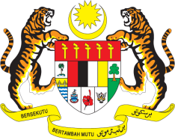

**STATEMENT BY MALAYSIA**

**REVIEW OF MEXICO**

**45TH SESSION OF THE UPR WORKING GROUP**

**22 JANUARY – 2 FEBRUARY 2024**

Malaysia commends Mexico’s various efforts aimed at tackling discrimination amongst vulnerable groups through the 2021-2024 National Programme for Equality and Non-Discrimination.

2. We also commend Mexico’s efforts to phase out 5 million of its people from poverty threshold.

3. In the spirit of constructive engagement, Malaysia recommends the following:

3.1 First, step up efforts to eliminate the gender pay gap between men and women in the labour market;

3.2 Second, continue efforts to reduce the early dropout among children and adolescents from schools; and

3.3 Third, take further steps to improve coordination on the implementation of a national policy to prevent, eradicate and criminalise human trafficking.

4. We wish Mexico a successful review.

Thank you.

**24 JANUARY 2024**

**GENEVA**