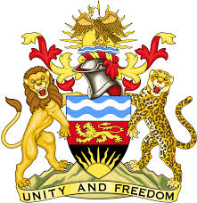

**REPUBLIC OF MALAWI**

**MALAWI STATEMENT ON THE UNITED MEXICAN STATES UNIVERSAL PERIODIC REVIEW**

**WEDNESDAY, 24TH JANUARY 2024**

**Mr. President**,

Malawi welcomes Mexico to this review and thanks the delegation for the comprehensive presentation.

Malawi notes the significant efforts made by Mexico in the promotion and protection of the human rights for instance the introduction of Traffic Light System for Assessing Compliance with International Human Rights-related Recommendations, used to analyse, evaluate and raise awareness of actions taken by the State to implement recommendations.

We make the following recommendations to Mexico:

1. Ensure that all complaints of excessive use of force, especially lethal force, by law enforcement and military personnel are promptly and impartially investigated; and
2. Adopt policies effective in reducing homicides and extrajudicial killings

We wish Mexico all the best at this review and in the implementation of the recommendations.

**Thank you, Mr. President**.