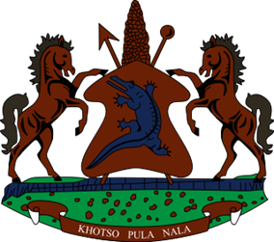

**STATEMENT BY THE KINGDOM OF LESOTHO DURING THE 4TH UPR REVIEW OF MEXICO**

**23 JANUARY 2024**

**Thank you, Mr. President,**

Lesotho welcomes the distinguished delegation of Mexico to the 4th UPR cycle. We applaud efforts made by the Government to prevent torture, inhuman or degrading treatment, by establish a national programme and a monitoring mechanism for cases involving sexual torture of women. We commend Mexico for addressing corruption within the public service by developing the 2019–2024 National Programme for Combating Corruption and Impunity and Improving Public Management.

Whilst noting the positive developments made, Lesotho wishes to make the following 3 recommendations for consideration by Mexico; 1. To strengthen measures to address the issue of prolonged and arbitrary detentions and ensure due process of the law prevails, for those already detained; 2. To continue efforts to address Child, Early and Forced Marriages which are most prevalent in the Northeast of Mexico and the Sur region and; lastly, to bolster efforts to improve access to health care services, especially reproductive services for women and girls.

We wish to conclude be wishing Mexico every success with this UPR Cycle.

I THANK YOU