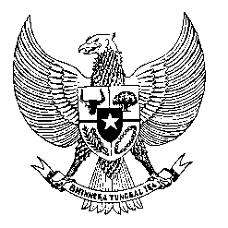

Permanent Mission

of the Republic of Indonesia to the UN, WTO,

and Other International Organizations

in Geneva

**STATEMENT BY THE DELEGATION OF THE REPUBLIC OF INDONESIA**

**AT THE 45th SESSION OF THE UPR WORKING GROUP**

**CONSIDERATION OF THE UPR REPORT OF MEXICO**

**24 JANUARY 2024**

**Thank you Mr. Vice President,**

* Indonesia thanks the distinguished Delegation of Mexico for presenting the report.
* We commend Mexico’s commitment to advancing human rights by strengthening the people’s constitutional rights and ratifying notable international human rights instruments since 2018.
* We also commend Mexico’s progress in supporting persons with disabilities, addressing poverty issues by raising the minimum wage and reducing the gender wage gap.
* In a constructive spirit, Indonesia recommends:

1. Ensure effective policies in preventing extrajudicial killings and guarantee civil security.
2. Continue efforts to prevent and combat trafficking in persons and adopt effective mechanisms for the identification and referral of trafficking victims.
3. Improve access to inclusive and high-quality education, particularly by targeting girls, minorities, and families living in extreme poverty.

* We wish Mexico a successful review.
* **Thank you.**