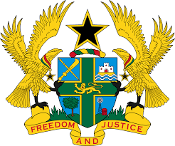

**STATEMENT BY GHANA DELIVERED BY ABA AYEBI-ARTHUR,MINISTR-COUNSELLOR, DURING THE 45TH SESSION OF THE UPR WORKING GROUP ON WEDNESDAY, 24TH JANUARY, 2024**

**UNIVERSAL PERIODIC REVIEW OF MEXICO**

Mr. President.

Ghana extends a warm welcome to the delegation of Mexico and thanks them for the presentation of their national report.

My delegation commends Mexico the Government for adopting a number of domestic legislations and action plans since the third UPR to promote and protect human rights. Of note are the National Programme for Equality and Non-Discrimination, the National Security Strategy and a national programme for the prevention and punishment of torture and other cruel, inhuman or degrading treatment or punishment.

To further advance respect for human rights in Mexico, Ghana offers the following recommendations:

1. **Continue to conduct investigations into incidents of enforced disappearances and bring perpetrators to justice;**
2. **Adopt comprehensive policies to combat violence against children; and**
3. **Continue to effectively implement laws to protect human rights defenders and journalist in the country.**

Ghana wishes Mexico a successful review.

I thank you.