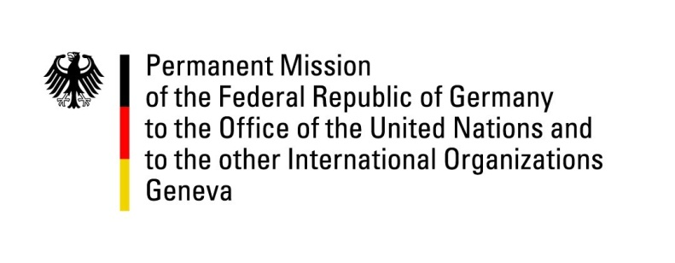

**United Nations Human Rights Council**

**45th Session of the UPR Working Group**

**Geneva, 24th of January 2023**

**German Recommendations and advance questions to**

**Mexico**

Mister President,

Germany welcomes the Mexican delegation.

Germany commends Mexico for its efforts to combat enforced disappearances as well as for its legislative and administrative advances in protecting human rights, especially the rights of women.

However, Germany remains concerned about widespread impunity of serious human rights abuses committed by organized criminal groups, including the ongoing intimidation of and violence against human rights defenders and journalists, disappearances and displacements, and persistent gender-based violence. Not holding perpetrators to account creates an environment conducive to further abuses.

Germany therefore recommends to:

* Enhance the state´s ability to effectively investigate and sanction human rights violations, including capacity-building and rule-of-law co-operation with the international community;
* Develop a comprehensive policy, together with human rights defenders and journalists, to prevent and protect them from violence, including a strategy to reduce impunity through more effective criminal prosecutions and strengthening of protection programs;
* Fully implement the law on enforced disappearances, including by strengthening the National Register of Disappeared Persons, guaranteeing participation of the victims´ families;
* Adopt and implement the law on forced internal displacement, together with an effective prevention strategy that addresses its root causes.

Thank you, Mister President.