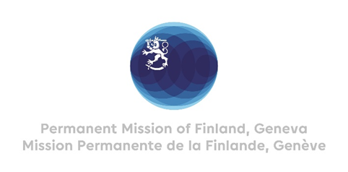

**44 Session of the UPR working group**

**Recommendations by Finland to Mexico**

**24th January 2024**

Mr. President,

Finland welcomes the engagement of Mexico in the UPR. Finland notes the ruling of the Supreme Court of Mexico from September 2023 to decriminalize abortion nationwide.

Finland recommends the following:

Firstly, fully implement the 2012 law for the protection of human rights defenders and journalists, and implement the recommendations of OHCHR Mexico regarding strengthening of the national protection mechanism for human rights defenders and journalists.

Secondly, take effective measures to prevent and combat violence against women, feminicide and disappearances to end impunity and guarantee the full implementation of women’s rights.

Finland wishes Mexico a successful UPR review.

Thank you.