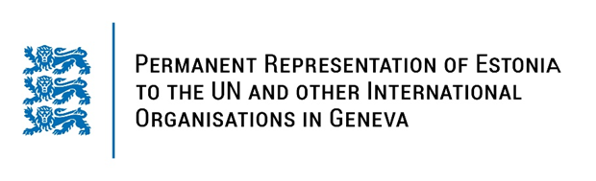

**Universal Periodic Review of Mexico**

**24 January 2024**

**Intervention by the delegation of Estonia**

Estonia warmly welcomes the delegation of Mexico to its fourth UPR. We thank Mexico for its national report and the information provided today.

Estonia welcomes the reforms taken by Mexico since the last UPR, such as the ones to guarantee women’s rights, to strengthen gender equality and to combat corruption, and encourages Mexico to continue its efforts to implement relevant laws, programs and policies. We welcome the Supreme Court’s ruling declaring the criminalization of abortion to be unconstitutional.

Estonia would like to offer the following recommendations to Mexico:

* harmonize national and state-level legislation and policies to guarantee safe and legal access to voluntary termination of pregnancy;
* ensure adolescents and youth’s unimpeded access to sexual and reproductive health information, counselling, education and services;
* take further measures to reduce gender stereotypes and gender inequalities, including by conducting inclusive awareness-raising campaigns on the principles of non-discrimination and gender equality;
* develop effective public policies to ensure that human rights defenders and journalists were able to carry out their work and activities freely, without fear of intimidation, harassment, reprisals or attacks.

Estonia wishes the delegation of Mexico all the success in the current review and in implementing the recommendations.

Thank you.