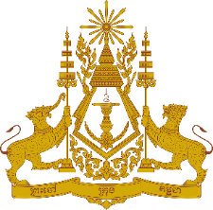

**PERMANENT MISSION OF THE KINGDOM OF CAMBODIA**

**TO THE UNITED NATIONS AT GENEVA**

**Statement of Cambodia**

At the 45th Session of the UPR Working Group

UPR of Mexico

24 January 2024

-------

Mr. President!

1. Cambodia warmly welcomes the distinguished delegation of Mexico and appreciates the comprehensive national report presented.
2. We commend the progress made by Mexico in the implementation of recommendations accepted during the Third UPR Cycle.
3. Cambodia applauds the actions taken by Mexico to safeguard the rights of person with disabilities, children, elderly persons, migrants, and other vulnerable groups.
4. In the constructive spirit, we would like to put forward two recommendations:
5. Continue strengthening efforts to combat human trafficking within the migrant and asylum-seeking community.
6. Continue efforts to improve both quality and accessibility of education for children and adolescents experiencing migration circumstances.
7. Finally, I wish the delegation of Mexico a successful review.

Thank you.

*\*\*\*\*\**