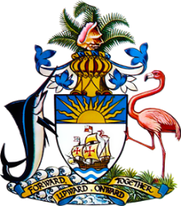

**Statement by Ms. Sasha Dixon, Counsellor**

**Permanent Mission of The Bahamas to the United Nations Office and Other International Organizations in Geneva**

**at the 45th Session of the Universal Periodic Review Working Group**

***Presentation on the National Report by the Government of Mexico***

**24 January 2024**

Thank you, Mr./Madam [Vice] President.

The Bahamas extends a warm welcome to the delegation of Mexico and thanks the country for its national report.

We commend Mexico on progress made in the field of human rights such as significantly augmenting the budget for ensuring compliance with human rights obligations; efforts undertaken through the 2019 National Security Strategy to combat violence and organized crime and successes achieved in reducing rates of multidimensional poverty and improving social security coverage.   
  
In a constructive spirit, The Bahamas respectfully recommends that Mexico:

1. Ensure that the National Council for the Prevention of Discrimination is adequately resourced to fulfil its mandate, with a view to addressing exclusion and social inequality, including among Indigenous and Afro-Mexican communities;
2. Ensure that the Gender Violence Alert Mechanism is adequately resourced and monitored so it is effective in achieving its objectives.

and

1. Take effective measures to ensure equal access to quality education and to reduce school dropout rates, especially within disadvantaged communities.

We wish the delegation of Mexico every success during its UPR process.

I thank you.