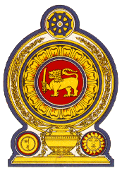

**45th Session of the Universal Periodic Review**

**Review of Mauritius**

**26 January 2024**

**Statement by the Democratic Socialist Republic of Sri Lanka**

Mr President,

Sri Lanka thanks the delegation of Mauritius for their presentation.

We commend progress of Mauritius since its last UPR. Sri Lanka notes with appreciation the measures taken to promote the enjoyment of human rights notably, the National Action Plan on Trafficking in Persons 2022-2026 and establishment of a Children’s Court.

In a constructive spirit, Sri Lanka recommends that Mauritius

-Promotes the rights of the child by ensuring their protection from exploitation.

-Ensure safety of women and advance opportunities for women’s participation in the labour force.

We wish Mauritius success in its UPR engagement.