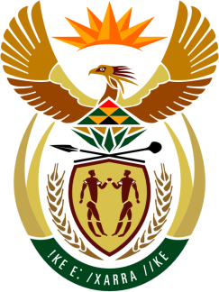

**SOUTH AFRICAN PERMANENT MISSION**

**TO THE UNITED NATIONS**

**AND OTHER INTERNATIONAL ORGANISATIONS**

**45th SESSION OF THE WORKING GROUP ON THE**

**UNIVERSAL PERIODIC REVIEW**

**Review of MAURITIUS**

**24 JANUARY 2024**

**(60 Seconds)**

**speaker no: 7**

***Check against delivery***

Mr. President,

South Africa welcomes the distinguished delegation of Mauritius to this UPR Session and wishes the country a successful review.

My delegation wishes to respectfully recommend that Mauritius:

1. Consider establishing a mechanism to coordinate and monitor the implementation of the national action plan on combating trafficking in persons;
2. Continue efforts to further reduce neonatal, infant and under-5 and maternal mortality rates, including by adequately resourcing the National Framework to improve Maternal Newborn Health (2019);
3. Consider renewing the National Child Protection Strategy and Action Plan (2014–2022).

South Africa commends Mauritius for its commitment to support the human rights pillar including through contributions made to the Voluntary Technical Assistance Trust Fund to assist the participation of Least Developed Countries and Small Island Developing States (SIDS).

I thank you.