sJamhuuriyadda Federaalka Soomaaliya  Ergada Joogtada Soomaliyeed ee Qaramada Midoobey ee Geneva, Switzerland. | 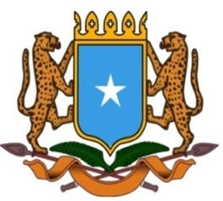 | جمهورية الصوما ل الفيدرالية  البعثة الدائمة لجمهورية الصومال بمكتب الأمم المتحدة بجنيف وبالوكالات المتخصصة بسويسرا

Permanent Mission of the Federal Republic of Somalia to the United Nations Office at Geneva and other International Organizations in Switzerland

Check Against Delivery
Statement by the Delegations of Somalia,
Hussen Abdi Musa, First Counsellor
at the Review of Republic of Mauritius, during the 45th Session of the UPR Working Group on Wednesday, 24 January, 2024 from 9:00 am to 12:30, in the Room XX of the Palais des Nations in Geneva, Speaker Number 6, Time: 1 minute and 00 seconds.

Thank you Mr. President,

Somalia warmly welcomes the distinguished delegation of the Republic of Mauritius to this fourth cycle of the UPR working group and thanks them for their comprehensive national report as well as the update provided today.
We welcome the various positive steps undertaken by the government of Mauritius to promote and protect fundamental human rights, including among others, the adoption of the Children’s Act and the creation of a new Children’s Court to better protect the rights of children.
We also commend the efforts of the government to enhance the public health service through the implementation of the Health Sector Strategic Plan (2020-2024) and the provision of free health services in all public institutions.

In a spirit of constructive dialogue, Somalia recommends the following:

1.Continue implementing the Health Sector Strategic plan (2020-2024).
2. Continue taking necessary measures to protect the environment and to address the damaging impact of climate change with the assistance of development partners
3. To pursue its efforts to promote the teaching of the Kreol Morisien.

Somalia wishes Mauritius a successful outcome in this review.

I Thank you Mr. President.

