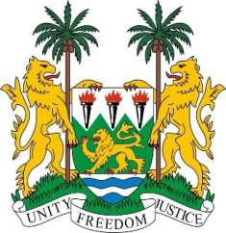

**45th Session of the UPR Statement**

**MAURITIUS**

Tuesday, 24 January, 2024

***Check against delivery***

**Mr President**,

Sierra Leone welcomes and thanks the **Honourable Maneesh Gobin, Minister of Foreign Affairs, Regional Integration and International Trade** and distinguished delegation of Mauritius and thanks them for their presentation.

Sierra Leone commends Mauritius' decision to make pre-primary and primary education free, and urges Mauritius to consider making secondary education free as well.

We also note and welcome the recent launch of the National Gender Policy (2022-2030) and the establishment of the National Strategy and Action Plan on Gender-Based Violence, as well as the establishment of the High-Level Committee on the Elimination of Gender-Based Violence.

In the spirit of constructive dialogue, Sierra Leone offers the following recommendations.

1. Consider ratifying the ICPRMW (Migrant Workers) and the ICPPED (Enforced Disappearances).
2. Continue efforts to address and eliminate gender based-violence, including by the operationalisation the Gender Based Violence Observatory.

1. Strengthen efforts to include human rights education in the national curriculum, particularly in relation to gender-based violence.

Sierra Leone wishes Mauritius every success in the implementation of the accepted recommendations during this fourth cycle.

Thank you, Mr President.