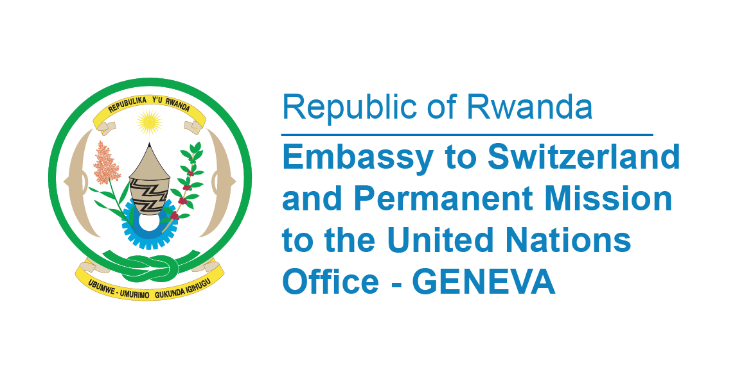

**45th Session of the UPR Working Group**

**Review of Mauritius**

**24th January 2024**

**Statement delivered by Ms. Betty DUSENGE, Second Counsellor at the Permanent Mission of the Republic of Rwanda**

Thank you, Mr. President,

Rwanda welcomes the high-level delegation of Mauritius and thank them for the presentation of their comprehensive National Report and oral updates.

Rwanda takes note of improvement made by the government of Mauritius since its previous UPR.

Rwanda applauds Mauritius establishment of the Children’s Court Act in 2020, which came into force in January 2023.

Rwanda further notes with appreciation the adoption of a Corporate Governance Scorecard by the government of Mauritius to raise the standards of corporate governance practices.

In the spirit of interactive dialogue, Rwanda recommends Mauritius the following;

* Consider ratifying the Optional Protocol to the International Covenant on Economic, Social and Cultural Rights;
* Consider acceding to the Second Optional Protocol to the International Covenant on Civil and Political Rights, aiming at the abolition of the death penalty;
* Ratifying the Optional Protocol to the Convention on the Rights of the Child on a communications procedure.

Finally, Rwanda wishes Mauritius a successful review.

**Thank you**