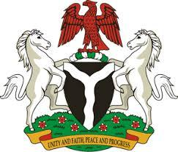

*Please check against delivery*

**HUMAN RIGHTS COUNCIL**

**45TH SESSION OF THE WORKING GROUP OF THE UPR**

**REVIEW OF THE PEOPLE’S REPUBLIC OF MAURITIUS**

**24TH JANUARY, 2024**

**STATEMENT BY NIGERIA**

**Mr. President,**

Nigeria warmly welcomes the delegation of the brotherly Republic of Mauritius to the presentation of its National Report and commends the Government for its efforts in implementing previous recommendations.

2. We commend the Government of Mauritius for its commitment to the right to education through free education initiatives, and further applaud its promotion of healthcare by offering free medical care.

3. In the spirit of constructive dialogue, Nigeria wishes to recommend for Mauritius to:

1. Intensify efforts to protect children from abuse and exploitation, particularly those who are victims of trafficking; and
2. Redouble efforts in the protection of women against domestic violence.

4. We wish Mauritius a very successful review process.

I thank you, Mr. President.