*Check against delivery*

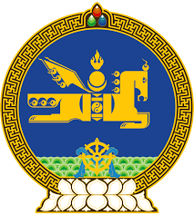

**45th SESSION OF THE UPR WORKING GROUP**

**MONGOLIA’S STATEMENT AT THE REVIEW OF MAURITIUS**

**24 January 2024, 09:00-12:30hrs**

Mongolia extends a warm welcome to the delegation of Mauritius.

My delegation welcomes the adoption of the law establishing children’s court in Mauritius, encourages their strengthening and further sharing of best practices regarding juvenile justice.

We applaud the launching of the National Gender Policy for 2022-2030 to eliminate gender-based discrimination and encourage effective monitoring of its implementation in partnership with the relevant stakeholders.

Mongolia recommends Mauritius:

**One.** To extend a standing invitation to UN special mandate holders;

**Two.** To continue its efforts to ensure the active participation of all members of society at all levels of public life;

**Three**. To step up its efforts to promote the participation of women in political life and their representation in decision-making positions in the public sector;

**Four.** To accelerate its work to eradicate gender-based and domestic violence.

I thank you.

---oOo---