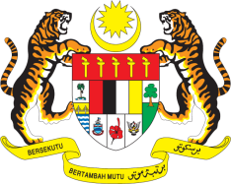

**STATEMENT BY MALAYSIA**

**REVIEW OF MAURITIUS**

**45TH SESSION OF THE UPR WORKING GROUP**

**22 JANUARY – 2 FEBRUARY 2024**

Malaysia welcomes Mauritius’ strong commitment to strengthen the protection of human rights through its social welfare system, including for the elderly, women and children.

3. In the spirit of constructive engagement, Malaysia recommends the following:

3.1 First, continue to increase its resilience and preparedness to mitigate the impacts of climate change including by taking into account the rights vulnerable groups in its climate change strategies;

3.2 Second, improve the accessibility and quality of health care, especially for vulnerable groups as well as people in remote and rural areas; and

3.3 Third, continue efforts to improve access and services in the education sector including for girls and those with special needs

4. We wish Mauritius a successful review.

Thank you.

**24 JANUARY 2024**

**GENEVA**