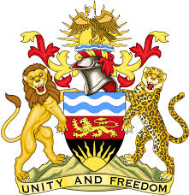

**REPUBLIC OF MALAWI**

**MALAWI STATEMENT ON THE REPUBLIC OF MAURITIUS UNIVERSAL PERIODIC REVIEW**

**WEDNESDAY, 24TH JANUARY 2024**

**Mr. President**,

Malawi welcomes Mauritius to this review and thanks the delegation for the comprehensive presentation.

Malawi notes the significant efforts made by Mauritius in the promotion and protection of the human rights since the last review in 2018, as evidenced by the measures taken to address recommendations.

We make the following recommendations to Mauritius:

1. Continue adopting necessary legislative and policy measures for the promotion and protection of economic, social and cultural rights;
2. Consider signing and ratifying the [Protocol to the African Charter on Human and Peoples' Rights on the Rights of Persons with Disabilities in Africa](https://au.int/en/treaties/protocol-african-charter-human-and-peoples-rights-rights-persons-disabilities-africa)
3. Continue with efforts to increase the number of women in decision making positions.

We wish Mauritius all the best at this review and in the implementation of the recommendations.

**Thank you, Mr. President**.