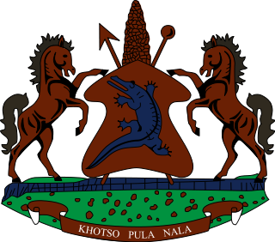

**INTERVENTION OF THE DELEGATION OF LESOTHO UNDER THE 4th UPR REVIEW OF MAURITIUS**

**24 JANUARY 2024**

**GENEVA, SWITZERLAND**

Thank you Mr. President,

Lesotho welcomes the distinguished delegation of Mauritius to their 4th UPR cycle, and thank them for the presentation of their National Report. We commend the Government for the strides made in fulfilling its treaty obligations, by submitting a substantial number of State Party Reports since their last review in 2018. We further welcome the measures undertaken to guarantee the right to health for all, by implementing health related strategies and policies, providing free medical care and establishing health care centres to treat specialised diseases, amongst others.

Cognisant of the remarkable progress made, Lesotho believes that there are areas that could be strengthened in order to further enhance the promotion and protection of the human rights of the people of Mauritius. In this regard, Lesotho wishes to make the following three recommendations for consideration by Mauritius 1. To strengthen measures to address police brutality and ensure that cases relating to abuse or brutality by the police officers are addressed timeously and effectively; 2. to bolster efforts to combat human trafficking and sexual exploitation of women and children; and lastly, to continue efforts to ensure access to quality education for children living in remote areas, particularly those from disadvantaged communities.

We wish Mauritius every success with this UPR cycle.

THANK YOU