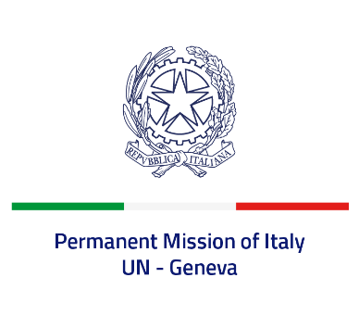

*Check against delivery*

**UPR 45 – Mauritius**

**Wednesday 24 January 2024, 9:00 – 12:30**

**Delivered by: Permanent Representative of Italy Amb. Vincenzo Grassi**

Thank you, Mister President.

We thank the distinguished delegation of Mauritius for their national report and presentation.

Italy appreciates the commitment of Mauritius to the UPR and welcomes the ratification of the *Convention on the Prevention and Punishment of the Crime of Genocide*.

We also welcome the efforts in the area of women’s and children’s rights, as well as the Supreme Court ruling of last October declaring unconstitutional the section of the Criminal Code which criminalized same-sex relations.

Italy would like to recommend to:

* *Ensure effective measures to prevent acts of torture and other forms of ill-treatment and that all allegations of torture and ill-treatment are thoroughly investigated and those responsible are brought to justice.*
* *Endorse the Safe Schools Declaration.*

We wish the delegation of Mauritius a successful review.

I thank you.