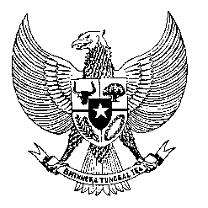

Permanent Mission

of the Republic of Indonesia to the UN, WTO,

and Other International Organizations

in Geneva

**STATEMENT BY THE DELEGATION OF THE REPUBLIC OF INDONESIA**

**AT THE 45th SESSION OF THE UPR WORKING GROUP**

**CONSIDERATION OF THE UPR REPORT OF MAURITIUS**

1. **JANUARY 2024**

* **Thank you Mr. Vice President,**
* Indonesia welcomes the delegations of Mauritius and thanks them for the report.
* We commend Mauritius's efforts to improve its judiciary and enhance the electoral system, especially regarding female representation.
* In line with our recommendation in the previous UPR cycle to redouble efforts to strengthen measures to protect children's rights, Indonesia welcomes the enactment of the Children's Act and the setting up of a new Children's Court.
* In a constructive spirit, we recommend Mauritius to:

1. Intensify efforts to protect children from abuse and exploitation, particularly in digital environments;
2. Continue taking necessary measures to mitigate the impacts of climate change on vulnerable populations, including through international collaborations;
3. Strengthen legal frameworks and enforcement mechanisms to combat trafficking in persons.

* Indonesia wishes Mauritius a successful UPR.

**Thank you.**