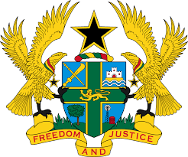

**STATEMENT BY GHANA DELIVERED BY ABA AYEBI-ARTHUR, MINISTER-COUNSELLOR ON WEDNESDAY, 24TH JANUARY, 2024**

**UNIVERSAL PERIODIC REVIEW OF MAURITIUS**

Thank you, Mr. Vice President.

Ghana welcomes the delegation of Mauritius to the UPR process and thank them for their national report.

We commend Mauritius’ unwavering commitment in implementing recommendations it accepted during the third UPR Cycle. We welcome in particular the progressive implementation of the National Human Rights Action Plan for 2012-2020. We further note with satisfaction the judiciary reforms to ensure an improved and faster administration of justice.

In the spirit of constructive dialogue, Ghana offers the following two recommendations:

1. **Continue to strengthen measures to ensure the protection of women’s and children’s rights, including adopting effective strategies to eliminate gender role stereotypes; and**
2. **Enhance efforts to combat racist media coverage and incidents of hate speech as well as hold the perpetrators accountable.**

Ghana wishes Mauritius every success with the review process.

I thank you.