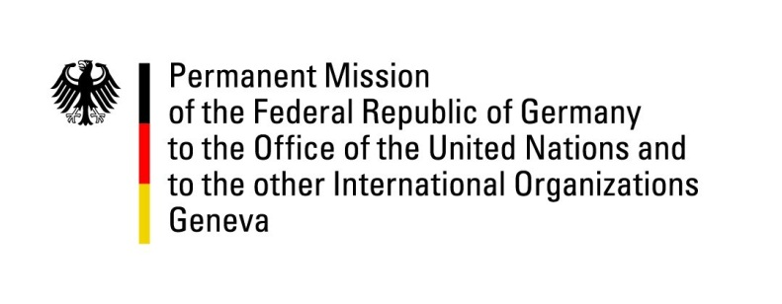

**United Nations Human Rights Council**

**45th Session of the UPR Working Group**

**Geneva, 24th of January 2023**

**German Recommendations and advance questions to**

**Mauritius**

Mister President,

Germany welcomes the delegation of Mauritius.

Germany commends Mauritius for its constant efforts to respect, protect and promote human rights, which has resulted in important advances in the reporting period. In particular, Germany commends Mauritius for the introduction of several laws to improve children´s rights and the recent decriminalization of homosexuality.

However, Germany remains concerned about infringements on the freedom of expression and on the rights to information and privacy reflected in cases of online surveillance, sanctioning of critical media outlets and detentions of journalists. In addition, Germany remains concerned about the rights of migrant workers and human trafficking.

Germany recommends to:

* Ensure that the Information and Communication Technologies Act is applied in a way that does not infringe on freedom of expression and the right to privacy
* Take adequate measures to protect migrant workers and their families, including by reinstating labor protection laws suspended during the Covid-19 pandemic;
* Adopt a comprehensive action plan and establish a body to coordinate government efforts to prevent, investigate, prosecute and sanction all forms of trafficking in persons.

Thank you, Mister President.