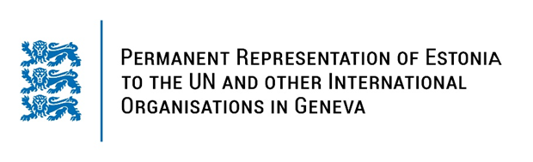

**Universal Periodic Review of Mauritius**

**24 January 2024**

**Intervention by the delegation of Estonia**

Estonia warmly welcomes the delegation of Mauritius to its fourth UPR. We thank Mauritius for its national report and the information provided today.

Estonia welcomes Mauritius’s efforts since the last UPR, in particular measures taken to implement the National Gender Policy and the National Strategy and Action Plan on the Elimination of Gender-Based Violence. Estonia remains concerned about restrictions on freedom of opinion and expression and peaceful assembly.

Estonia would like to offer the following recommendations to Mauritius:

* decriminalize defamation and include it in the Civil Code in accordance with international standards;
* ensure the protection of freedom of expression by reviewing vague and broad offences in the Information and Communication Technologies Act;
* take concrete measures to provide scientifically accurate education on sexual and reproductive health and rights by including it in school curricula;
* ratify the Second Optional Protocol to the International Covenant on Civil and Political Rights, aiming at the abolition of the death penalty.

Estonia wishes to the delegation of Mauritius all success in the current review and in implementing the recommendations.

Thank you!