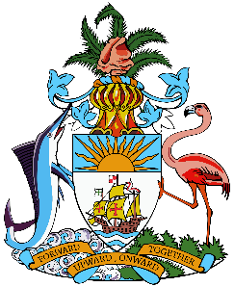

Statement by Ms. Sasha Dixon, Counsellor
Permanent Mission of The Bahamas to the United Nations Office and Other International Organizations in Geneva
at the 45th Session of the Universal Periodic Review Working Group
Presentation of National Report by the Government of Mauritius
24 January, 2024

Thank you, Mr. Vice President,
The Bahamas thanks Mauritius for the national report and commends achievements made since the last review.
In particular, we positively acknowledge efforts to modernize the judiciary through wide-ranging administrative and functional reforms, to promote respect and recognition of People of African Descent through the new Intercontinental Slavery Museum and to create an enabling environment for the increased participation of women in the workforce.

As a fellow archipelagic Small Island Developing State (SIDS), we recognise the challenges faced by Mauritius, including the need to duplicate services and adapt to the disproportionate impacts of climate change.

To encourage further progress, The Bahamas recommends that Mauritius:

- Extend a standing invitation to all thematic special procedures mandate holders of the Human Rights Council (HRC);
- Consider strengthening the National Mechanism for Implementation, Reporting and Follow-up (NMIRF) to enable it to coordinate the implementation of recommendations from all human rights mechanisms;
and

- Take steps to ensure the enrolment and retention of all children for the duration of compulsory education, including by increasing access for children in remote areas and those from disadvantaged communities.

We wish Mauritius every success in this UPR process.

I thank you.

