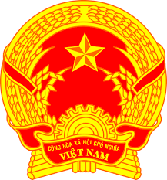

**Statement of the Socialist Republic of Viet Nam**

*45th Session of the UPR Working Group  
Review of Jordan*

*(Geneva, 24 January 2024)*

*Mister President,*

Viet Nam welcomes the delegation of Jordan. We appreciate the national UPR report and progress that Jordan has made.

We commend Jordan’s efforts and achievements in follow-up to the recommendations received during the Third UPR cycle, especially its efforts in the alignment of national legislations with international human rights treaties that Jordan has ratified.

In a spirit of constructive dialogue, Viet Nam would like to make two recommendations to Jordan:

1. Continue its efforts in promoting the participation of young people and women in climate-related actions and initiatives launched by Jordan.

2. Explore further measures in teaching children to think critically in the digital world, as well as protecting them from cyber-bullying, extremism, and fake news.

We wish Jordan a successful UPR cycle.

*Thank you, Mister President./.*

***Time: 01 minute 10 seconds***