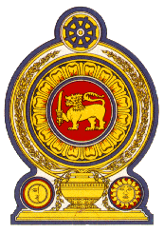

**45th Session of the Universal Periodic Review**

**Review of Jordan**

**31 January 2024**

**Statement by the Democratic Socialist Republic of Sri Lanka**

Mr President,

Sri Lanka extends a warm welcome to the delegation of Jordan and appreciates the presentation made.

We commend Jordan’s progress in protecting and promoting human rights since its last UPR. Sri Lanka notes with appreciation the measures taken to promote the enjoyment of human rights including the launch of the National Strategy for Women 2020-2025 and establishment of a wider institutional network in relation to women’s affairs.

In a constructive spirit, Sri Lanka recommends that Jordan:

-Ratifies the Convention on the protection of the Rights of All Migrant Workers and Members of Their families

-Promotes the rights of the child by ensuring their safety and access to education.

-Continue to advance the rights of women including protection from exploitation, harassment and gender-based violence.

We wish Jordan success in its UPR engagement.