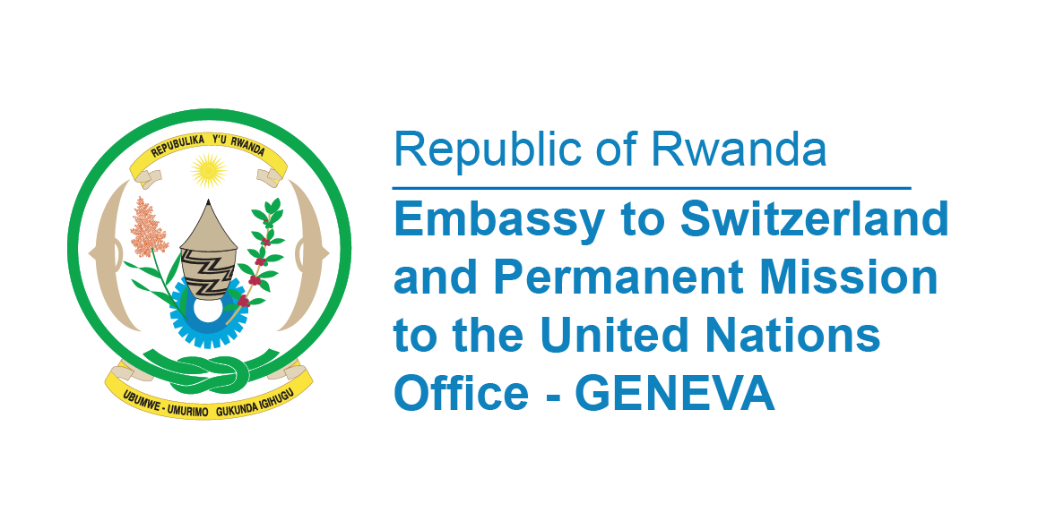

**45th Session of the UPR Working Group**

**Review of Jordan**

**25th January 202**

**Statement delivered by Ms. Betty DUSENGE, Permanent Mission of the Republic of Rwanda**

Thank you, Mr. President,

Rwanda welcomes the distinguished delegation of the Kingdom of Jordan and thanks them for the presentation of a comprehensive National Report.

We applaud the establishment of several units and directorates in ministries and governmental institutions for the purpose of promoting human rights.

Rwanda further notes with appreciation the adoption of national human rights plans and strategies to address matters relating to women, juvenile justice, care for older persons, children, elimination of child labour, the rights of persons with disabilities, the media and communication with the judiciary

In a spirit of constructive dialogue, **Rwanda recommends Jordan the following;**

* Consider ratifying the Second Optional Protocol to the International Covenant on Civil and Political Rights, aiming at the abolition of the death penalty;
* Acceding to the International Convention on the Protection of the Rights of All Migrant Workers and Members of Their Families,
* Ratifying the Optional Protocol to the Convention on the Rights of the Child on a communications procedure.

Rwanda wishes Jordan a successful review.

**Thank you**