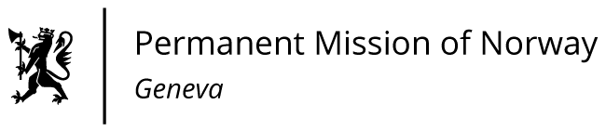

**STATEMENT**

**45th UPR Session of the Human Rights Council**

**on the human rights situation in Jordan,**

**as delivered by Ms Sigrun S. HOLTER**

**First Secretary, Permanent Representative of Norway in Geneva.**

Check against delivery

25 January 2024

President,

Norway welcomes the positive steps taken by Jordan, including recent electoral legislation and reforms that - inter alia - aims to improve women’s political participation. We encourage Jordan to ensure that domestic legislation is compliant with international obligations, and to prioritize its implementation.

Norway recommends that Jordan:

1. Ensures that national laws protect the right to freedom of expression, association and peaceful assembly, including amending the criminal law regulating the use of the internet.

2. Withdraw [its] reservations to article 9 and 16 of the Convention on the Elimination of All Forms of Discrimination Against Women.

3. Take concrete measures to limit the use and duration of administrative detention and to guarantee access to legal assistance.

Thank you