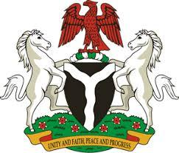

*Please check against delivery*

**HUMAN RIGHTS COUNCIL**

**45TH SESSION OF THE WORKING GROUP OF THE UPR**

**REVIEW OF THE HASHEMITE KINGDOM OF JORDAN**

**25TH JANUARY, 2024**

**STATEMENT BY NIGERIA**

**Mr. President,**

Nigeria welcomes the delegation of the Hashemite Kingdom of Jordan to the presentation of its National Report and commends the Government for its commitment to the implementation of previous recommendations.

2. We take positive note of legal reforms undertaken by the Government of Jordan to align domestic legislation with international human rights laws. We further commend Jordan for its initiatives to promote women’s rights, foster gender equality, and the enacted legislation to address domestic violence.

3. While recognising the various efforts by Jordan to promote and protect human rights, Nigeria wishes to recommend the following:Top of Form

1. To continue its efforts at improving the criminal justice system; and
2. To enhance access to education for all students with special needs, by implementing a training program to educate teachers.

4. Finally, we wish Jordan a very successful review process.

I thank you, Mr. President.