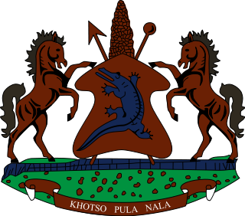

**INTERVENTION OF THE DELEGATION OF LESOTHO UNDER THE UPR REVIEW OF JORDAN**

**25 JANUARY 2024**

**GENEVA, SWITZERLAND**

Thank you Mr. President,

Lesotho welcomes the distinguished delegation of Jordan to the 4th Cycle of the UPR Process. We take positive note of the measures taken by the government to promote the rights of women by amending the Constitution with a view to enabling their right to integration and participation in public life. We particularly commend the Government for enacting the Child Rights Act in 2022.

Despite these positive developments, Lesotho is of the view that there is still more that could be done to improve the promotion and protection of human rights in the country. It is in this context, that Lesotho wishes to make the following recommendations, for consideration by Jordan 1. To continue efforts to strengthen the Continue efforts to improve places of detention in accordance with international standards; 2. Enhance efforts to raise awareness of the importance of green bonds in promoting climate finance and their impact on investment; and lastly, to strengthen measures to eradicate gender stereotypes that seem to be deeply rooted in most communities in the country and integrate the concepts of justice and equality into the school curriculum.

We wish to conclude by wishing Jordan every success with this UPR cycle.

THANK YOU