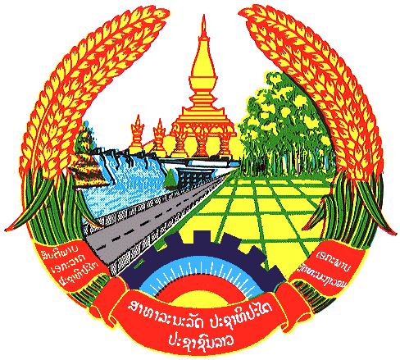

**Statement by the delegation of the Permanent Mission of the Lao PDR to the United Nations and other International Organizations in Geneva**

**at the 45th Session of UPR Working Group**

**Geneva, 25 January 2024**

(Speaking time 1.10 minute)

Review of Jordan (9:00 - 12:30)

1. Thank you, Mr. President.
2. My delegation warmly welcomes the delegation of Jordan and thanks for the presentation of the national report.
3. The Lao PDR commends the progress made by Jordan in improving its national legislative and institutional frameworks to promote and protect human rights. We appreciate its strong commitments to promote gender equality and empowerment of women, including the development of national strategy for women.
4. The Lao PDR would like to make 3 following recommendations:
5. **⁠Consider to integrate the concepts of justice and equality into all curriculums and textbooks.**
6. **⁠Continue efforts to raise the awareness of working women of their rights in the labor market.**
7. We wish Jordan every success in this UPR cycle.
8. I thank you, Mr. President.