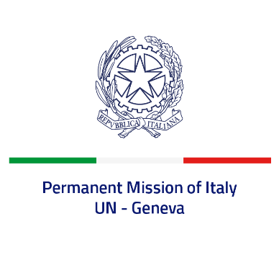

*Check against delivery*

**UPR 45 – Kingdom of Jordan**

**Thursday 25 January 2024, 9:00 – 12:30**

**Delivered by: Permanent Representative of Italy Amb. Vincenzo Grassi**

Thank you, Mister President.

We thank the distinguished delegation of the Kingdom of Jordan for their national report and presentation.

Italy appreciates the commitment of Jordan to the UPR and welcomes efforts to improve the protection of human rights at national level, including with regard to gender equality and women’s empowerment.

Italy would like to recommend to:

* *Consider the adoption of a moratorium on the death penalty.*
* *Take further steps to tackle all forms of discrimination, in particular against women.*
* *Adopt measures to prevent and fight incidents of torture and refer cases of alleged torture by security officials to independent civil courts rather than police courts.*
* *Enhance efforts to revise the use of administrative detention.*

We wish the delegation of Jordan a successful review.

I thank you.