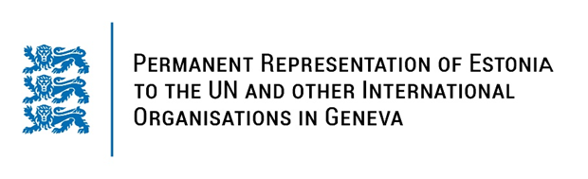

**Universal Periodic Review of Hashemite Kingdom of Jordan**

**25 January 2024**

**Intervention by the delegation of Estonia**

Estonia warmly welcomes the delegation of Hashemite Kingdom of Jordan to its fourth UPR. We thank Jordan for its national report and the information provided today.

Estonia would like to acknowledge Jordan’s ongoing work to improve human rights, such as the adoption of the Child Rights Act, promotion of inclusive education, and adoption of national plans and policies that enhance women’s rights. We encourage Jordan to continue its efforts towards greater inclusion and diversity in education by ensuring equal access also to the most vulnerable groups.

Estonia would like to offer the following recommendations to Jordan:

* enact a comprehensive anti-discrimination legislation on all prohibited grounds, including effective measures to identify and address all forms of discrimination;
* repeal all discriminatory provisions against women and girls in legislation;
* ensure unrestricted access to the Internet as well as the privacy of internet communications for all members of society and safe flow of information without violating the freedom of opinion and expression;
* ratify the Second Optional Protocol to International Covenant on Civil and Political Rights, aiming at the abolition of the death penalty;
* ratify the Optional Protocol to the Convention against Torture and other Cruel, Inhuman or Degrading Treatment or Punishment (OP-CAT).

Estonia wishes to the delegation of Jordan all success in the current review and in implementing the recommendations.

Thank you.