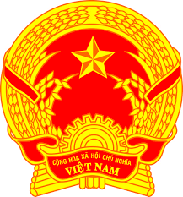

**Statement of the Socialist Republic of Viet Nam**

*45th Session of the UPR Working Group  
Review of Congo*

*(Geneva, 30 January 2024)*

*Mister Vice-President,*

Viet Nam welcomes the delegation of The Republic of the Congo and thanks it for the presentation of the national UPR report.

We commend Congo’s efforts to implement its recommendations from the previous UPR Cycle, especially the enactment of the National Development Plan 2022-2026 that contributed to job creation and poverty reduction. We also acknowledge Congo’s improved healthcare strategies through the capacity building of public health services, and providing health centres with appropriate equipment, medicines and human resources.

In a spirit of constructive dialogue, Viet Nam makes two recommendations to Congo:

1. First, continue its efforts in providing equitable education and vocational training in rural areas through the construction of school infrastructure.

2. Second, increase the availability of training and capacity-building programmes for women wishing to hold public office or to enter the professional business world.

In conclusion, Viet Nam wishes The Republic of the Congo every success with this UPR cycle.

*Thank you, Mister Vice-President./.*

**Word count: 158 words (1 min 20 sec)**