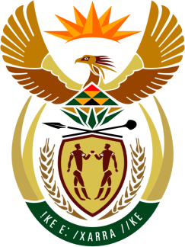

**SOUTH AFRICAN PERMANENT MISSION**

**TO THE UNITED NATIONS**

**AND OTHER INTERNATIONAL ORGANISATIONS**

**45th SESSION OF THE WORKING GROUP ON THE**

**UNIVERSAL PERIODIC REVIEW**

**Review of the REPuBLIC OF CONGO**

**30 JANUARY 2024**

**(90 Seconds)**

**speaker no: 83**

***Check against delivery***

Mr. President,

South Africa welcomes the distinguished delegation of the Republic of Congo to this UPR Session of the 4th cycle.

My delegation commends the Republic of Congo’s commitment to promoting and protecting human rights including through training provided for public employees and civil society actors in the use of international and regional human rights protection mechanisms, as well on the implementation of UPR recommendations.

South Africa wishes to respectfully recommend that the Republic of Congo:

1. continue efforts to increase investment in the health sector towards ensuring quality health for all;
2. provide training in children’s rights to judges, prosecutors and police officers, while allocating additional resources to children’s courts; and
3. intensify efforts to ensure timely birth registration and issuance of birth certificates, throughout its territory.

South Africa wishes the Republic of Congo a successful review.

I thank you.