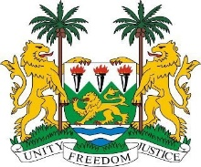

**SIERRA LEONE**

**45th Session of the UPR**

**THE CONGO**

Tuesday, 30 January 2024

**Mr President,**

Sierra Leone welcomes the distinguished delegation of the Congo and thanks them for the presentation of their national report.

My delegation commends the Congo on its human rights training efforts with international support in the use of international and regional human rights protection mechanisms. We applaud the Congo’s collaboration with the special rapporteur on the rights of Indigenous people.

Sierra Leone further commends the Congo’s accession to the 1954 Convention relating to the Status of Stateless Persons and the 1961 Convention on the Reduction of Statelessness.

In the spirit of constructive engagement, Sierra Leone would like to suggest the following recommendations.

**1. Ratify the International Convention for the Protection of All Persons from Enforced Disappearance.**

**2. Establish a national mechanism to further protect children with albinism and eliminate all forms of discrimination they face.**

**3. Introduce legislative changes for the protection of victims of gender-based violence.**

**5. Take concrete action to ensure compliance with international standards on the prevention of torture, cruel, inhuman, and degrading treatment.**

In conclusion, Sierra Leone wishes the Congo every success in completing this fourth review cycle.

Thank you, Mr President.