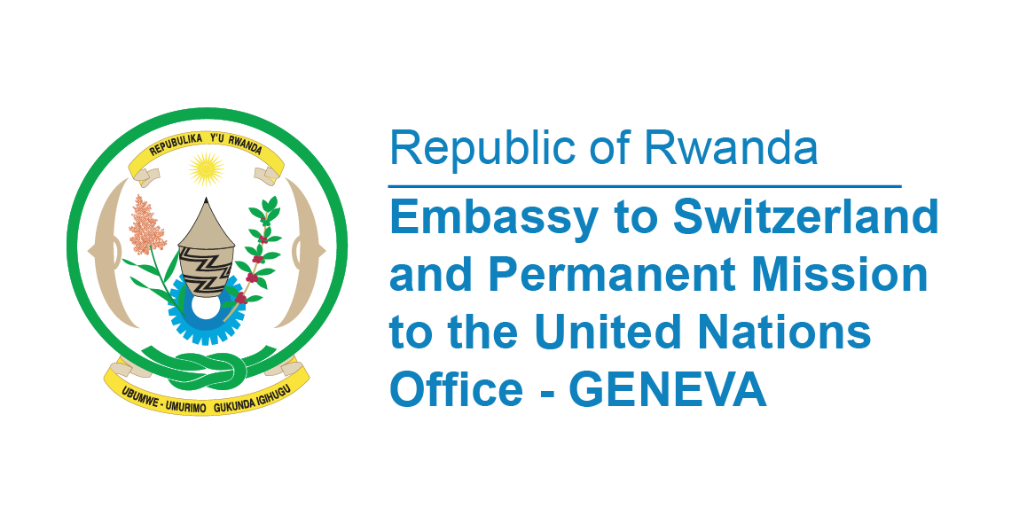

**45th Session of the UPR Working Group**

**Review of Congo**

**30th January 2024**

**Statement delivered by Ms. Betty DUSENGE, Second Counsellor at the Permanent Mission of the Republic of Rwanda**

Thank you, Mr. President,

Rwanda welcomes members of the distinguished delegation of the Republic of Congo and thanks them for the presentation of their National Report.

Rwanda highly commends the progress of the Government of Congo in regards to regulatory framework since her third cycle of UPR by ratifying about eight international human rights instruments and the well indicated process of acceding to about seven more instruments.

We noted with appreciation the establishment of a National Human Rights Commission to ensure that the country has a body to monitor the promotion and protection of human rights.

We further commend the setting up of a virtual platform for monitoring the implementation of the recommendations made during the universal periodic review, in partnership with the Subregional Centre for Human Rights and Democracy in Central Africa.

In a spirit of constructive dialogue, Rwanda recommends Congo to:

* Consider adopting a comprehensive definition of discrimination against women, in line with article 1 of the Convention on the Elimination of All Forms of Discrimination against Women, that covers all prohibited grounds of discrimination, including direct and indirect discrimination in the public and private spheres, and intersecting forms of discrimination.

Finally, Rwanda wishes Congo a successful review.

**Thank you, Mr. President,**