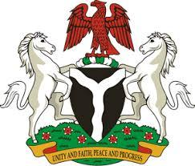

*Please check against delivery*

**HUMAN RIGHTS COUNCIL**

**45TH SESSION OF THE WORKING GROUP OF THE UPR**

**REVIEW OF THE REPUBLIC OF CONGO**

**30TH JANUARY, 2024**

**STATEMENT BY NIGERIA**

**Mr. President,**

Nigeria warmly welcomes the delegation of the brotherly Republic of the Congo to the presentation of its National Report and commends the Government for its continued cooperation with human rights mechanisms and efforts in implementing previous recommendations.

**2.** We take very positive note of the ratification of various international human rights instruments by the Congo and persistent efforts to strengthen its legal and institutional frameworks, in accordance with international human rights law. We further applaud the Congo for concerted efforts to eradicate child labour and improve children’s access to education.

3. While recognising the various efforts by the Government of the Congo to promote and protect human rights, Nigeria wishes to recommend the following:

1. To scale up efforts in the implementation and enforcement of measures to  protect the rights of women, children and persons with disabilities;
2. To continue to strengthen its legal and institutional frameworks for the promotion and protection of human rights; and
3. To intensify efforts to mobilize resources and galvanize international support to enhance its capacity to promote and protect human rights.

4. Finally, we wish the Republic of the Congo a very successful review process.

I thank you Mr President.