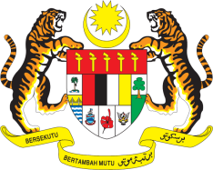

**STATEMENT BY MALAYSIA**

**REVIEW OF CONGO**

**45TH SESSION OF THE UPR WORKING GROUP**

**22 JANUARY – 2 FEBRUARY 2024**

Malaysia thanks Congo for the presentation of its national report.

1. Malaysia welcomes Congo’s national health policy, which seeks to improve the quality of health services by providing health centres with appropriate equipment, medicines and human resources. Malaysia also commends Congo on the adoption of the National Strategy for Girls’ Enrolment and the sectoral education strategy 2021–2030, which have helped to improve education facilities and increase trained teachers nationwide.
2. In the spirit of constructive engagement, Malaysia recommends the following:
   1. First, improve women’s access for formal employment by providing trainings and capacity building activities; and
   2. Second, strengthen efforts to improve school infrastructure in rural and remote areas to ensure access for girls to high-quality education, in particular at the secondary level.

4. We wish Congo a successful review.

Thank you.

**30 JANUARY 2024**

**GENEVA**