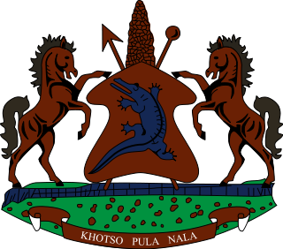

**INTERVENTION OF THE DELEGATION OF LESOTHO DURING THE 4th UPR CYCLE OF CONGO**

**30 JANUARY 2024**

**GENEVA, SWITZERLAND**

Thank you Mr. President,

Lesotho welcomes the distinguished delegation of the Congo to the 4th cycle of the UPR process. We recognise the notable efforts made by Congo, in ensuring constructive collaboration with human rights bodies and mechanisms by receiving special mandate holders in the country and submitting state party report to treaty monitoring bodies. We particularly welcome the strides taken to eliminate gender-based discrimination thorough the enactment of laws and public education.

To this end, wishes to make the following recommendations for consideration by Congo 1. To beef up measures to prohibit all forms of torture by security personnel and ensure that victims of torture and ill-treatment receive reparation; 2. Continue efforts to guarantee the independence of the judiciary by allocating additional financial and human resources in order to ensure its proper functioning; and lastly, to continue to strengthen measures to eliminate gender based violence.

We wish the Congo every success with this UPR cycle

THANK YOU