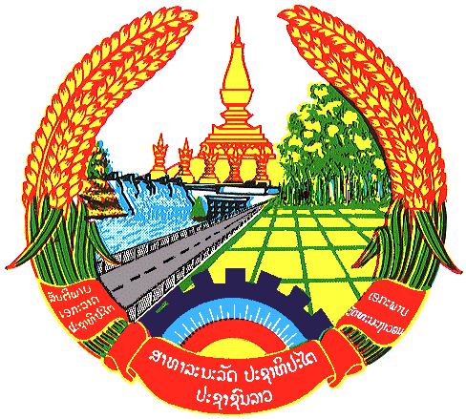

**Statement by the delegation of the Permanent Mission of the Lao PDR to the United Nations and other International Organizations in Geneva**

**at the 45th Session of UPR Working Group**

**Geneva, 30 January 2024**

(Speaking time 1.20 minute)

Review of Congo (14:30 - 18:00)

1. Thank you, Mr. President.
2. My delegation warmly welcomes the delegation of Congo and thanks for the presentation of the national report.
3. The Lao PDR commends Congo for its firm commitments to promote and protect human rights in the country by ratifying a number of international human rights instruments and developing national legal and institutional frameworks in many areas, including gender equality, violence against women, human trafficking, among others.
4. The Lao PDR would like to make 2 following recommendations:
5. **Continue efforts to strengthen the implementation of the national programmes and measures on poverty reduction as provided in the National Development Plan 2022-2026; and**
6. **Take further steps to accelerate national process towards ratifying the UN Convention against Transnational Organized Crimes and ensuring its implementation.**
7. We wish Congo a successful UPR review.
8. I thank you, Mr. President.