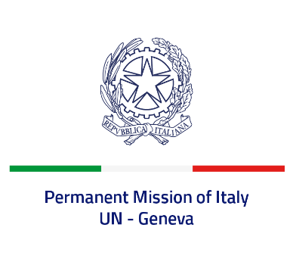

*Check against delivery*

**UPR 45 - Congo**

**Tuesday 30 January 2024, 14:30 - 18:00**

**Delivered by: Ambassador Vincenzo Grassi, Permanent Representative of Italy**

Thank you, Mister President.

We thank the distinguished delegation of the Republic of Congo for its presentation.

Italy welcomes the adoption in 2022 of the “Mouebara Act” on combating violence against women and in 2019 of the Act No. 22 on combating trafficking in persons.

We also look forward for the finalization of the ratification process of the Second Optional Protocol to the International Covenant on Civil and Political Rights, aiming at the abolition of the death penalty.

Italy seizes this opportunity to offer the Republic of Congo the following recommendations:

* *Fight impunity and fully implement national legislation relating to human rights, ensuring adequate funding of the relevant national policies and institutions;*
* *Consider adopting a law for the protection of human rights defenders;*
* *Guarantee the enjoyment of the rights of freedom of expression, association and peaceful assembly, in line with international standards;*
* *Strengthen efforts to prevent arbitrary detentions and torture and to improve the condition of detainees.*

We wish the Republic of Congo a successful review.

I thank you.