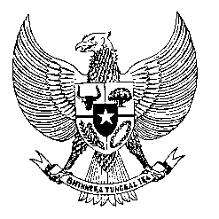

Permanent Mission

of the Republic of Indonesia to the UN, WTO,

and Other International Organizations

in Geneva

**STATEMENT BY THE DELEGATION OF THE REPUBLIC OF INDONESIA**

**AT THE 45th SESSION OF THE UPR WORKING GROUP**

**CONSIDERATION OF THE UPR REPORT OF THE CONGO,**

**30 JANUARY 2024**

**Thank you, Vice President,**

* Indonesia welcomes the delegations of the Congo and thanks them for presenting the report.
* We note the Congo’s committed efforts and legislative steps to promote gender equity and gender equality and eliminate violence against women.
* In a constructive spirit, Indonesia recommends the Congo, the following:

1. Strengthen the healthcare system to increase maternal and child mortality rates, including through ensuring adequate healthcare facilities, addressing accessibility issues in remote areas, and improving national vaccination program;
2. Continue to develop and implement comprehensive policies and legislation that specifically address the rights and needs of persons with disabilities;
3. Continue to seek international cooperation and assistance in developing and implementing effective training programs focusing on human rights, the rule of law, and the prohibition of torture and other forms of ill-treatment.

* We wish the Congo a successful UPR.

**Thank you.**