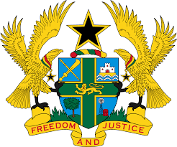

**STATEMENT BY GHANA DELIVERED BY ABA AYEBI-ARTHUR,MINISTER COUNSELOR ON TUESDAY, 30TH JANUARY, 2024**

**REVIEW OF CONGO**

Mr. Vice President.

Ghana welcomes the delegation of Congo to the UPR and welcomes the ratification of a number of International Human Rights Instruments since the previous UPR. We acknowledge the establishment of the National Human Rights Commission, the High Council for Freedom of Communication, as well as the Women’s Advisory Council.

We further commend Congo for efforts made to the protection and promotion of Gender equality and elimination of violence against women, as well as Children’s Right.

In the spirit of constructive dialogue, Ghana recommends the following for Congo’s consideration:

1. **Accede to the Optional Protocol to the Convention against Torture and other Cruel, Inhumane or Degrading Treatment or Punishment (OP-CAT);**
2. **Accede to the Optional Protocol to the Convention on the Elimination of all Forms of Discrimination against women (OP-CEDAW); and**
3. **Continue efforts to combat discrimination and violence against women and girls.**

To this end, Ghana wishes Congo a successful review process.

I thank you.