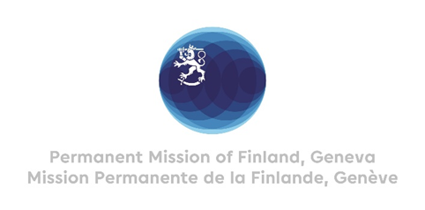

**45 Session of the UPR working group**

**Recommendations by Finland to the Republic of the Congo**

**30th January 2024**

Thank you Mr. Vice-President,

Finland appreciates the engagement of the Republic of the Congo in the UPR process. We welcome passing the law on the fight against violence against women in 2022 as an important step towards increased accountability over sexual and gender based violence.

In a constructive spirit, Finland respectfully recommends the Republic of the Congo to:

1. One, ratify the Convention for the Protection of All Persons from Enforced Disappearance.
2. Two, ratify the Optional Protocol to the Convention on the Elimination of All Forms of Discrimination against Women.
3. Three, extend an open and standing invitation to all Special Procedure mandate holders.

Finland wishes the Republic of the Congo every success with the follow up and implementation of the recommendations received during this fourth cycle of the UPR process.

I thank you.