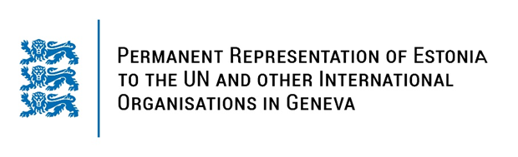

**Universal Periodic Review of the Congo**

**30 January 2024**

**Intervention by the delegation of Estonia**

Estonia warmly welcomes the delegation of the Congo to its fourth UPR. We thank the Congo for its national report and the information provided today.

Estonia welcomes the positive steps taken by the Government to improve the human rights situation since its previous UPR, such as adoption of law on the fight against violence against women and the law against human trafficking. Estonia urges the Congo to implement its strategy for reproductive, maternal, neonatal, child and adolescent health for 2022–2026 and to ensure access of women to health-care services, in particular in rural areas.

Estonia would like to offer the following recommendations to the Congo:

* repeal all discriminatory provisions against women and girls in legislation and adopt a comprehensive definition of discrimination against women;
* take concrete measures to raise awareness on children's rights and to address violence against children, including about the prohibition of corporal punishment in all settings;
* ratify the Second Optional Protocol to International Covenant on Civil and Political Rights, aiming at the abolition of the death penalty.

Estonia wishes to the delegation of the Congo all success in the current review and in implementing the recommendations.

Thank you!