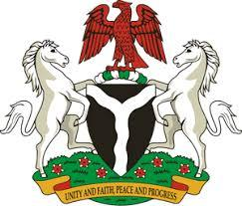

*Please check against delivery*

**HUMAN RIGHTS COUNCIL**

**45TH SESSION OF THE WORKING GROUP OF THE UPR**

**REVIEW OF THE PEOPLE’S REPUBLIC OF CHINA**

**23RD JANUARY, 2024**

**STATEMENT BY NIGERIA**

**Mr. President**,

Nigeria warmly welcomes the delegation of the People’s Republic of China. We applaud the Chinese Government for its initiatives that have resulted in a remarkable reduction of poverty and enhanced the economic and social rights of millions of its citizens.

2. In the spirit of constructive dialogue, we recommend China:

1. To improve human rights education for its citizens by implementing comprehensive awareness-raising programs; and
2. To enhance its legal system and strengthen judicial safeguards for the promotion and protection of human rights of all.

3. Finally, we wish China a very successful review process.

I thank you