*Check against delivery*

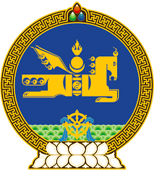

**45th SESSION OF THE UPR WORKING GROUP**

**MONGOLIA’S STATEMENT AT THE REVIEW OF CHINA**

**23 January 2024, 09:00-12:30hrs**

Mongolia cordially welcomes the delegation of China to the 4th cycle of UPR and wishes them a productive review.

Mongolia welcomes China’s accession to the Convention on Forced Labour (1930) and Convention on the Abolition of Forced Labour (1957).

We further note with appreciation the launching of the medium and long-term action plans for the protection of women, children, and people with disabilities, and encourages their effective implementation.

In the spirit of constructive dialogue, Mongolia would like to recommend China:

**One.** To continue its efforts to combat trafficking in persons;

**Two.** To take necessary measures to protect and promote cultural diversity;

**Three.** To continue its efforts to address all forms of violence against women and girls, to promote gender equality and to increase women’s representation in political and public life.

I thank you.

---oOo---